SMART IoT ENABLED LPG GAS LEAKAGE DETECTOR
BATCH-02
16121A1270 | N. VEERANJANEYULU
16121A12B2 | V. TEJASREE
16121A1262 | K. MAANVITHA
17121A1215 | D. SASI KUMAR
17121A1226 | G. VANITHA
17121A1259 | M. V. RANGA SWAMY



Department of Information Technology
SREE VIDYANIKETHAN ENGINEERING COLLEGE
(AUTONOMOUS)
(Affiliated to JNTUA, Ananthapuram, Approved by AICTE, Accredited by NBA &amp; NAAC)
Sree Sainath Nagar, Tirupati – 517 102, A.P.,
(2018 -2019)

TABLE OF CONTENT

- INTRODUCTION

- DESCRIPTION

2.1) FUNCTIONAL REQUIREMENTS

2.1.1) USER INTERFACES
2.1.2) HARDWARE INTERFACES
2.1.3) SOFTWARE INTERFACES
2.2) NON-FUNCTIONAL REQUIREMENTS

2.2.1) PERFORMANCE REQUIREMENTS
- WORK PLAN

3.1) METHODOLOGY
3.2) TIME SCHEDULE
- SYSTEM DESIGN
4.1) SEQUENCE DIAGRAM
- PROCEDURE

- ROLES AND RESPONSIBILITIES
- COST
- REFERENCES

- INTRODUCTION
Internet of Things has become important factor now-a-days to bring the technology into our home and office. By making the place smart, the day-to-day activities are becoming more easier. The development of home automation has become mandatory in homes as people are moving towards to the smart home concepts. With the help of assistant systems of IoT the normal routine activities like turning ON the light can be implemented with just a single command. With these comforts flowing into a person’s life, it has become essential to protect it from damages and accidents. As only the regular works has become smart, the things used are still the same like Gas cylinder in homes. According to the reports, over 1500 LPG accidents happen in India every day. This is equivalent to the death of 1500 people including the children. Even the neighborhood is affected in a single accident. So there comes the need to bring in technology to prevent accidents.

2. DESCRIPTION
OBJECTIVE:
The primary objective of the project is to detect the gas leakage of LPG cylinders, which are commonly used in Indian homes, and alarm the user and the surrounding neighborhood using IoT. Open source IoT software called “Thingspeak” is used for this project. The software has feature to connect with Node MCU Microcontroller and can also connect the user’s mobile to send SMS using IFTTT web service .MQ5 LPG gas sensor is used for sensing the leakage. A buzzer is connected along with the circuit to indicate the user.

2.1 FUNCTIONAL REQUIREMENTS:
USER REQUIREMENTS:
The user should have the LPG detector application so that he receives the message whenever the gas leakage occurs and this message is received when he is in online with the device. Else the alarm is buzzed in the offline state.
HARDWARE REQUIREMENTS:
- Node MCU Micro-controller
- MQ5 Gas Sensor
- WIFI Buzzer
- PCB
- Connecting Wires
SOFTWARE REQUIREMENTS:
- Arduino IDE
- Thing Speak
- IFTTT web service

2.2 NON-FUNCTIONAL REQUIREMENTS
PERFORMANCE REQUIREMENTS:
Gas sensor will be efficient only within the range of the source. If the application is in the offline state then the user may not receive any kind of message regarding the leakage.
3. WORK PLAN
3.1 METHODOLOGY:
- Hardware Development:
Gather all the hard ware requirements and connect them to the circuit.

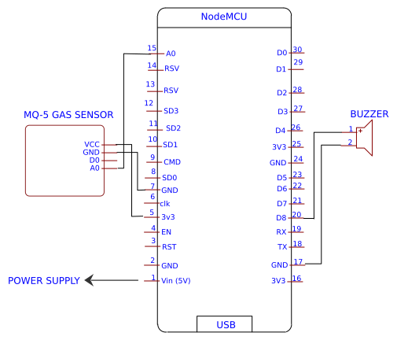

2) Software Development:
Develop a code for the processor that is incorporated with the sensing unit. Add buzzer to the system which alerts the user when there is a leakage.
3) Cloud Connection:
Connect the Node MCU to the “Things speak” cloud that records all the data that is sensed.
4) React to channel activity with text message from IFTTT:
Based on the data sensed, if gas level meets the condition specified ,then message is sent to the user about the leakage of the gas.

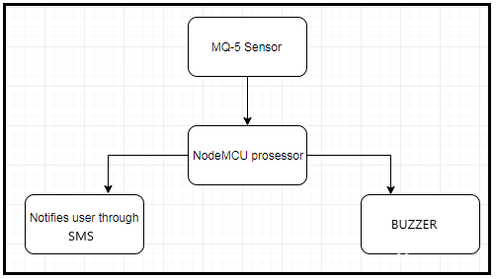
Architecture:

3.2) TIME SCHEDULE:
TIME |  | OUTCOME
Week1 | 2 days | Gathering all the requirements and circuit connections.
Week1 | 4 days | Connecting things to the cloud through things speak.
Week 2 | 6 days | Enabling message using IFTTT

4. SYSTEM DESIGN:
4.1 SEQUENCE DIAGRAM: A sequence diagram simply depicts interaction between objects in a sequential order i.e. the order in which these interactions take place. We can also use the terms event diagrams or event scenarios to refer to a sequence diagram. Sequence diagrams describe how and in what order the objects in a system function. These diagrams are widely used by businessmen and software developers to document and understand requirements for new and existing systems.
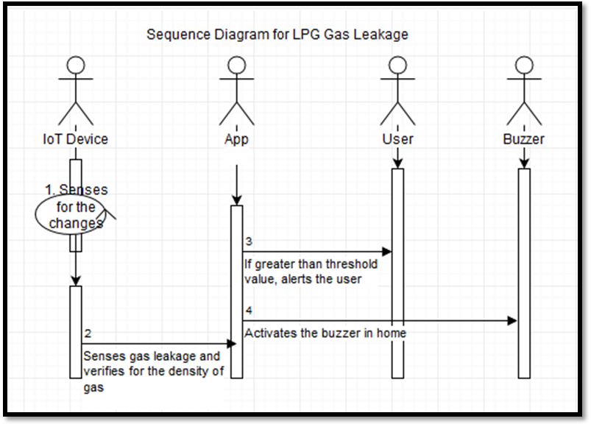

5. PROCEDURE
All the components are gathered together and connected in the following way
MQ5 GAS SENSOR | Connected to | NODE MCU
VCC pin | Connected to | 3v pin
A0 pin | Connected to | A0 pin
GND pin | Connected to | GND pin

BUZZER | Connected to | NODE MCU
Black wire | Connected to | GND pin
Red wire | Connected to | D7 pin

Steps to connect to Things Speak cloud
Visit www.thingspeak.com and click on the "Get Started" button to make a free account.
Now click on the "New Channel" Give it a name and select two fields.
Click on the "Make Public?" check box option. Finally click on the "Save Channel" button.
Press new channel and select the API keys tab . Copy the "Write API Key" , we will use it in the next step.
Now add this API Key in the code
Once the code editing is done upload it & Use a Gas/Cigarette lighter near sensor in gas leak condition you will see a change in sensor value in serial monitor and also able to see push API key data update in monitor.
React to Channel Activity with Text Message from IFTTT
Create an IFTTT Applet
You can set the IFTTT webhooks service to use web requests to trigger an action. The incoming action is an HTTP request to the web server and the outgoing action is a text message.
1) Create an IFTTT account, or log into your existing account.
2) Create an Applet. Select My Applets, and then click the New Applet button.

3) Select input action. Click the word this.

4) Select the Webhooks service. Enter Webhooks in the search field. Select the Webhooks card.
5) Complete the trigger fields. After you select Webhooks as the trigger, click the Receive a web request card to continue. Enter an event name. Here the event name is LPG Gas. Click Create Trigger.
6) Select the resulting action. Click the word that. The trigger word this is now the Webhooks icon. Enter SMS in the search bar, and select the SMS box.
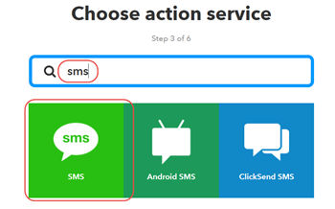

7) Select Send me an SMS, and then enter the text message information. You can pass data about the event that triggered your message using ingredients. For example, including {{Event Name}} adds the event name to your text message. Click Create action to finish the new Applet.
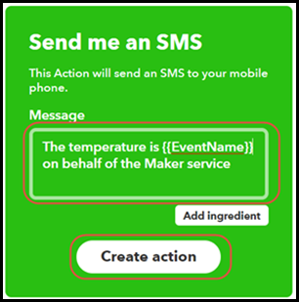

8) Retrieve your Webhooks trigger information. Select My Applets > Services, and search for Webhooks. Select Webhooks, and then click the Documentation button. You see your key and the format for sending a request. Enter the event name. The event name for this example is TooCold.
https://maker.ifttt.com/trigger/{event}/with/key/XXXXXXXXXXXXXXXXXXXXXX
https://maker.ifttt.com/trigger/TooCold/with/key/XXXXXXXXXXXXXXXXXXXXXX
You can test the service using the test button or by pasting the URL into your browser. The IFTTT event trigger is not always instantaneous. Now create a ThingHTTP to complete the trigger request.

Create a ThingHTTP
The ThingHTTP app lets you trigger predefined HTTP requests with an API key and a GET request from the web or from a device. This example shows how to use ThingHTTP to trigger Webhooks at IFTTT.
- Choose Apps > ThingHTTP, and select New ThingHTTP.
- Edit your ThingHTTP settings.
  - Choose a Name.
  - Enter the URL from the Webhooks documentation. The URL for this example has the form https://maker.ifttt.com/triigger/toocold/with/key/xxxxxxxxxxxxxxxxxxxxxx.
  - For Method, enter GET.
- To send custom values in your message from IFTTT, add value1=YOUR_VALUE to the Body field. Change YOUR_VALUE to the value or text you want to send.
- Save the ThingHTTP. Now create a React to trigger this ThingHTTP based on your channel data.
Create a React to Your Data
The React app can evaluate your ThingSpeak channel data and trigger other events. Create an instance of the React app that triggers when the house is too cold. Choose Apps > React, and then click New React.
- Choose a Name.
- Select On Data Insertion for Test Frequency.
- Choose your gas level channel for the Condition.
- Select the appropriate field, in this case Field 1.
- Set the requirement to is greater than.
- Set the temperature level, in this case 790.
- Select ThingHTTP as the Action, and choose the name of the ThingHTTP you defined previously.
- In Options, choose Run action each time condition is met.

Trigger Your Message
Once the gas level in the channel reaches the set point for your React, you receive a text message on your device.
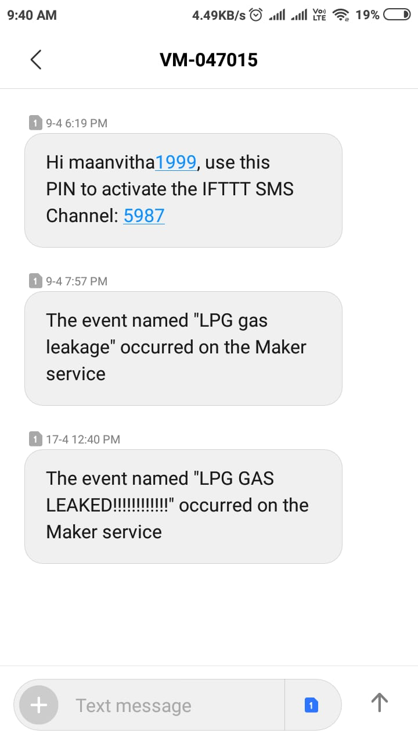
CODE
#include <ESP8266WiFi.h>
#include <ESP8266HTTPClient.h>
WiFiClient client;
String thingSpeakAddress= "http://api.thingspeak.com/update?";
String writeAPIKey;
String tsfield1Name;
String request_string;
HTTPClient http;
float sensor=A0;
float gas_value;
int sensorThres=775;
int g=gas_value;
const int buzzer =D7;
void setup() {
// initialize digital pin LED_BUILTIN as an output.
pinMode(LED_BUILTIN, OUTPUT);
pinMode(sensor,INPUT);
pinMode(buzzer, OUTPUT);
Serial.begin(9600);
WiFi.disconnect();
WiFi.begin("sai98","siva1998");
while ((!(WiFi.status() == WL_CONNECTED))){
delay(300);
}
}
// the loop function runs over and over again forever
void loop() {
gas_value=analogRead(sensor);
int g=gas_value;
//Serial.println(gas_value);
if(g>790) {
digitalWrite(LED_BUILTIN, HIGH);
Serial.println(g);
digitalWrite(buzzer, HIGH);
}
else{
digitalWrite(LED_BUILTIN, LOW);
Serial.println(g);
digitalWrite(buzzer, LOW);
}

/* gas_value=analogRead(sensor);
Serial.println(gas_value);
delay(2000); */
if (client.connect("api.thingspeak.com",80)) {
request_string = thingSpeakAddress;
request_string += "key=";
request_string += "NLJNWWQC2OOFBEP2";
request_string += "&";
request_string += "field1";
request_string += "=";
request_string += g;
http.begin(request_string);
http.GET();
http.end();
}
delay(3000);
}

6. ROLES AND RESPONSIBILITIES:
NAME-ROLE | RESPONSIBILITIES
N.Veeranjeneyulu - Analyser | Analyse the problem and collect the required information
V.Tejasree - Developer | Implements circuit connections with sensor
K.Maanvitha – Tester | Tests all the circuit connections and working condition of device.
G.Vanitha – Analyser | Collects all hardware requirements
M.V.Ranga Swamy - Developer | Develops code for the module
D.Sashi Kumar - Tester | Test the message acknowledgement.

7. COST:
Device | Specification | Cost
Node MCU | EP8266 | 355
MQ5 Sensor | LPG SENSOR | 160
Piezo Buzzer | - | 26
PCB | - | 40
Node MCU Cable | - | 40
TOTAL |  | 621

8. REFERENCES:
  - http://karkhanaindia.blogspot.com/2017/12/iot-lpg-gas-sensor-logging-with-nodemcu.html
  - https://www.hackanons.com/2018/01/iot-based-lpgcng-gas-leakage-detection.html
  - https://www.instructables.com/id/Gas-Sensor-Using-Arduino/
  - https://circuitdigest.com/microcontroller-projects/arduino-based-lpg-gas-leakage-detector-alarm
  - https://www.researchgate.net/publication/329828278_Intelligent_Gas_Leakage_Detection_System_with_IoT_Using_ESP_8266_Module
  - https://iot-playground.com/blog/2-uncategorised/53-esp8266-wifi-gas-sensor-arduino-ide

